Practical 09

Aim: Web Storage and State Management: Use localStorage and sessionStorage to persist data across page reloads. Create a theme switcher or preference saver that remembers settings. give detailed lab manual Javascript, with all examples explanation and task

Theory

What is Web Storage?
Web Storage allows web applications to store data locally within the user’s browser.
It provides key–value storage that is faster and more secure than cookies.
There are two main types:

Storage Type | Lifetime | Shared Across Tabs? | Typical Use
localStorage | Persistent (until manually cleared) | Yes | Preferences, theme, login tokens
sessionStorage | Temporary (cleared when tab closes) | No | Session-based data, temporary settings

Key Differences Between localStorage and sessionStorage
Feature | localStorage | sessionStorage
Lifetime | Stays even after browser closes | Removed when tab or window closes
Scope | Shared across all tabs/windows | Specific to one tab
Storage Limit | ~5MB | ~5MB
Example Use | Saving theme or language preference | Saving form input until user submits

Web Storage API Methods
Method | Description | Example
setItem(key, value) | Stores a value | localStorage.setItem("theme", "dark");
getItem(key) | Retrieves a value | localStorage.getItem("theme");
removeItem(key) | Deletes a key | localStorage.removeItem("theme");
clear() | Clears all storage | localStorage.clear();
key(index) | Returns key at given index | localStorage.key(0);

Example 1: Basic localStorage and sessionStorage
<!DOCTYPE html>
<html lang="en">
<head>
<meta charset="UTF-8">
<title>Web Storage Example</title>
</head>
<body>
<h2>Web Storage Demo</h2>

<input type="text" id="username" placeholder="Enter your name">
<button onclick="saveData()">Save</button>
<button onclick="loadData()">Load</button>
<button onclick="clearData()">Clear</button>

<p id="output"></p>

<script>
function saveData() {
let name = document.getElementById("username").value;
localStorage.setItem("userName", name);
sessionStorage.setItem("sessionName", name);
alert("Data saved!");
}

function loadData() {
let localName = localStorage.getItem("userName");
let sessionName = sessionStorage.getItem("sessionName");
document.getElementById("output").innerHTML =
`LocalStorage: ${localName} <br> SessionStorage: ${sessionName}`;
}

function clearData() {
localStorage.clear();
sessionStorage.clear();
document.getElementById("output").innerHTML = "Storage cleared!";
}
</script>
</body>
</html>
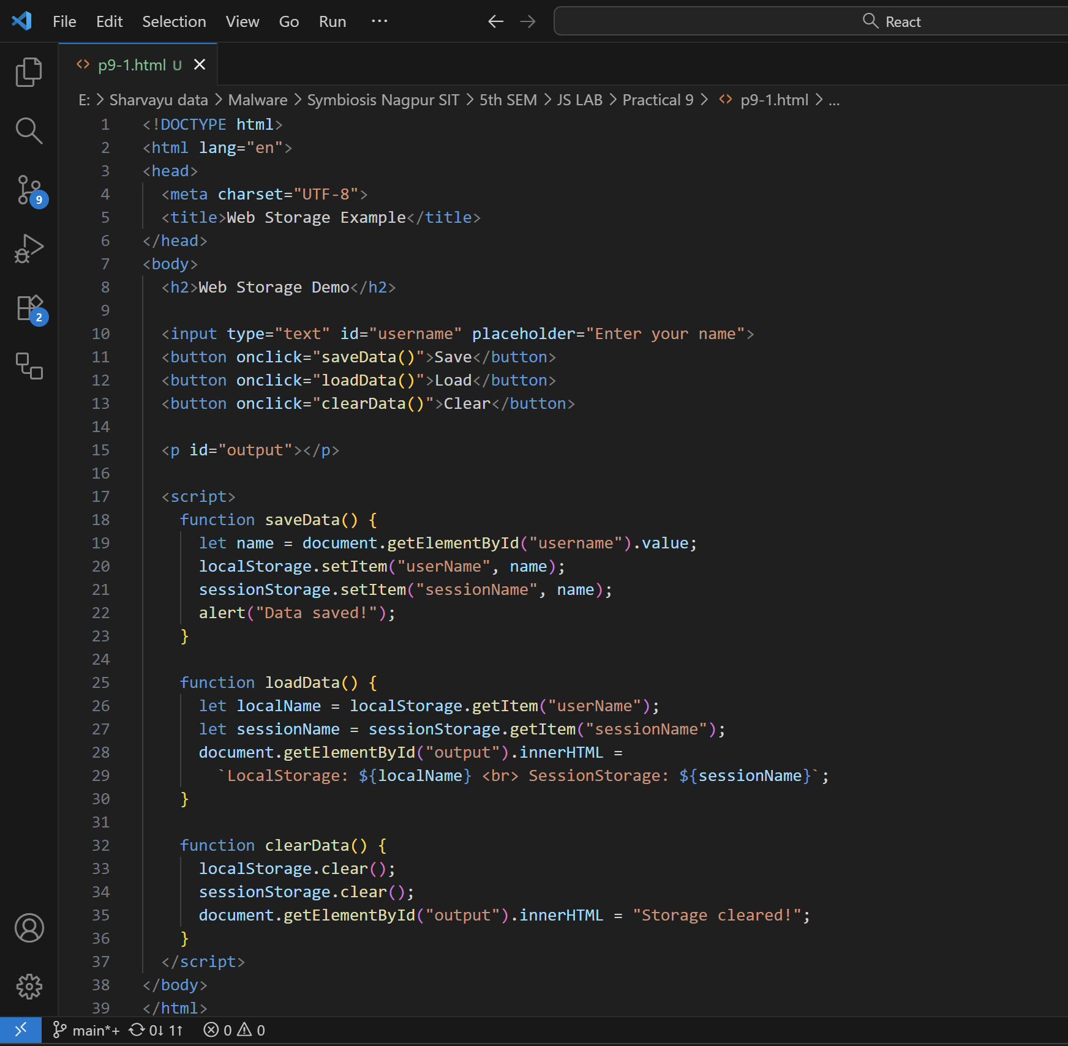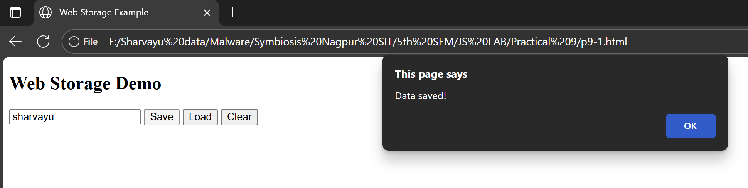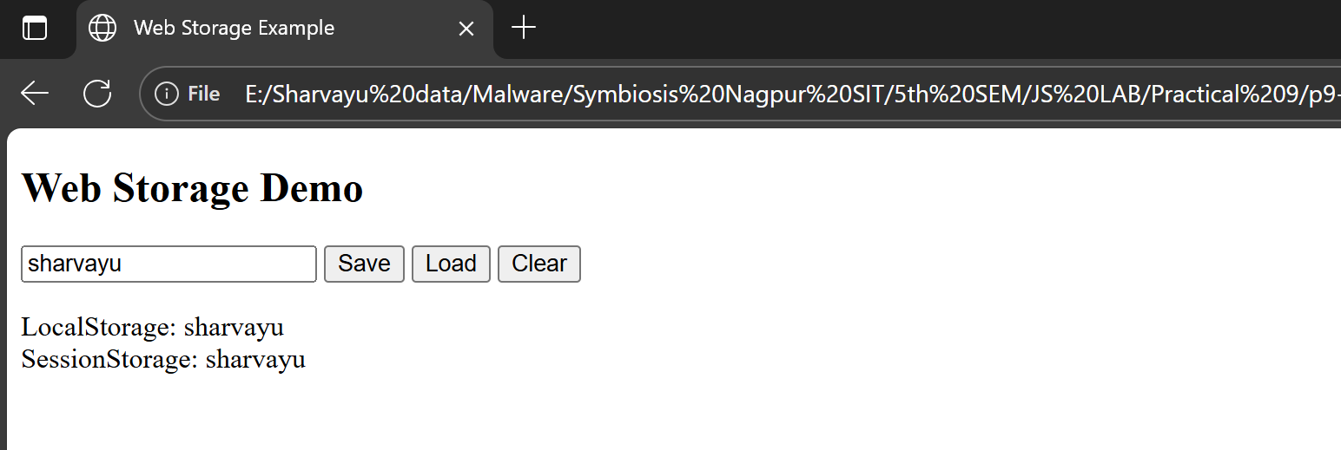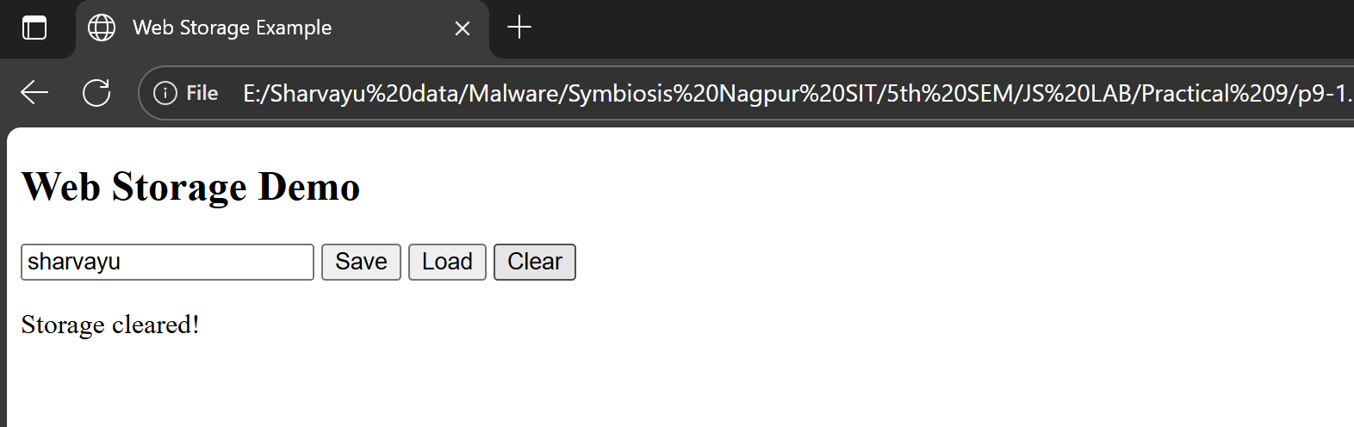

Explanation
- Data entered in the text box is stored both in localStorage and sessionStorage.
- Reloading the page:
localStorage value persists.
sessionStorage value remains until tab is closed.
- Closing the tab clears sessionStorage only.

Task 1: Verify Persistence
- Open Developer Tools → Application → Storage → Local Storage.
- Enter a name and click “Save”.
- Reload page → Load data → You’ll still see localStorage data.
- Close tab → Reopen → sessionStorage data disappears.
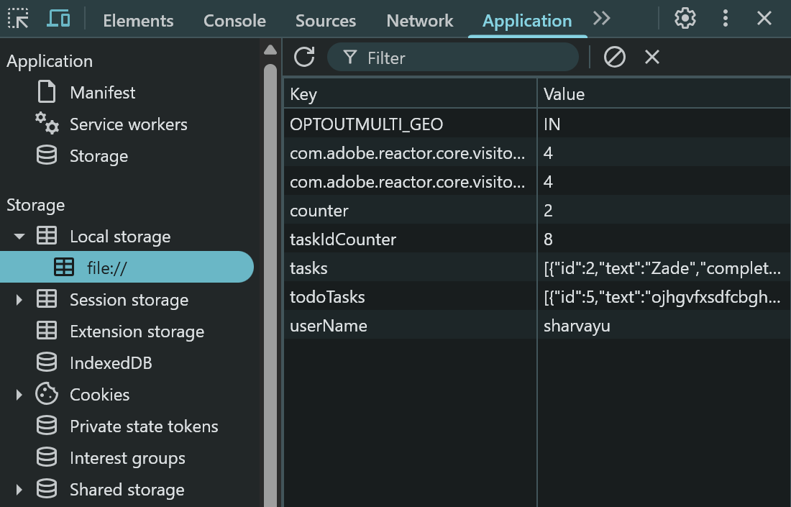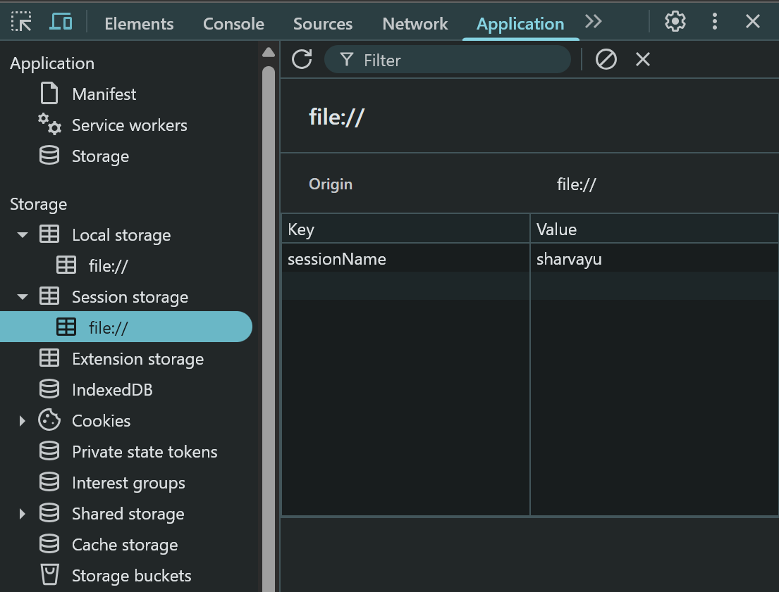

Example 2: Theme Switcher Using localStorage
<!DOCTYPE html>
<html lang="en">
<head>
<meta charset="UTF-8">
<title>Theme Switcher</title>
<style>
body {
font-family: Arial;
text-align: center;
transition: background-color 0.5s, color 0.5s;
}
.dark {
background-color: #121212;
color: white;
}
.light {
background-color: #ffffff;
color: black;
}
button {
margin: 10px;
padding: 10px 20px;
border: none;
cursor: pointer;
border-radius: 5px;
}
</style>
</head>
<body>
<h1>Theme Switcher with localStorage</h1>
<button id="toggleTheme">Toggle Theme</button>

<script>
const body = document.body;
const btn = document.getElementById("toggleTheme");

// 1. Load theme from localStorage on page load
const savedTheme = localStorage.getItem("theme") || "light";
body.classList.add(savedTheme);

// 2. Update button text
btn.textContent = savedTheme === "dark" ? "Switch to Light Mode" : "Switch to Dark Mode";

// 3. Toggle theme and save to localStorage
btn.addEventListener("click", () => {
const newTheme = body.classList.contains("dark") ? "light" : "dark";
body.className = newTheme; // switch theme
localStorage.setItem("theme", newTheme);
btn.textContent = newTheme === "dark" ? "Switch to Light Mode" : "Switch to Dark Mode";
});
</script>
</body>
</html>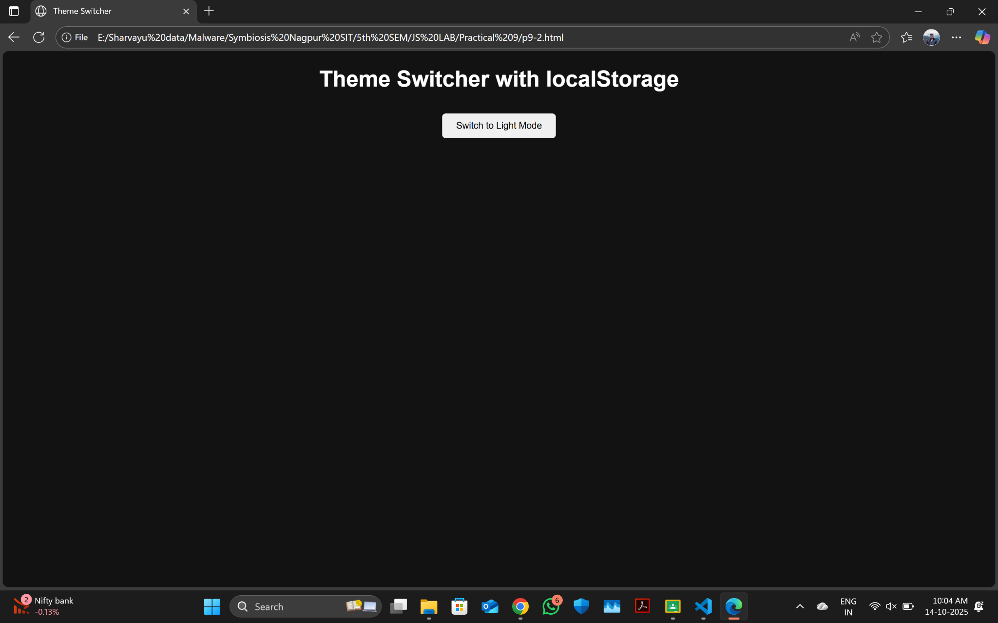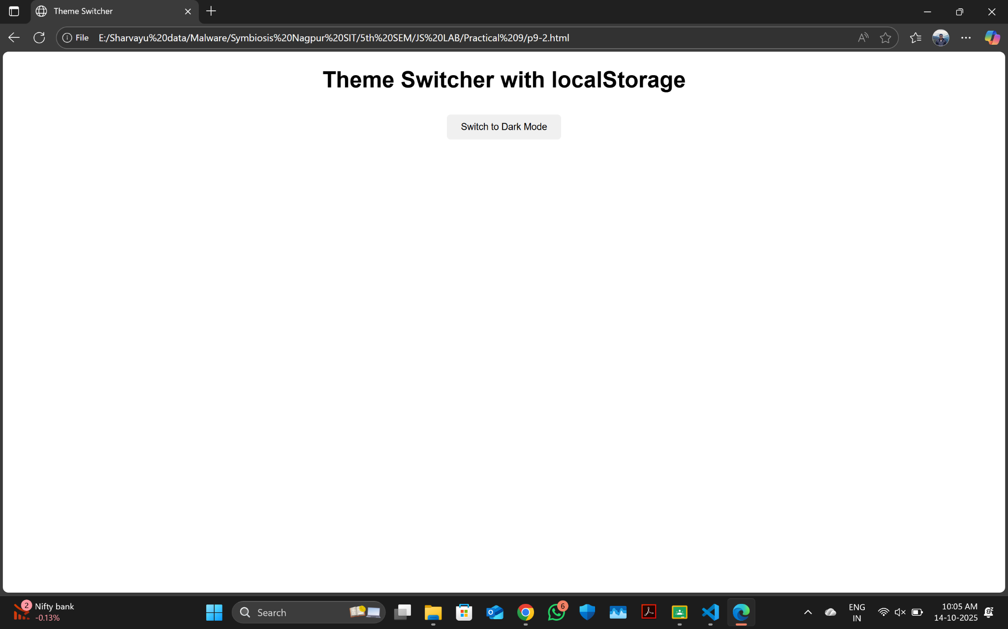
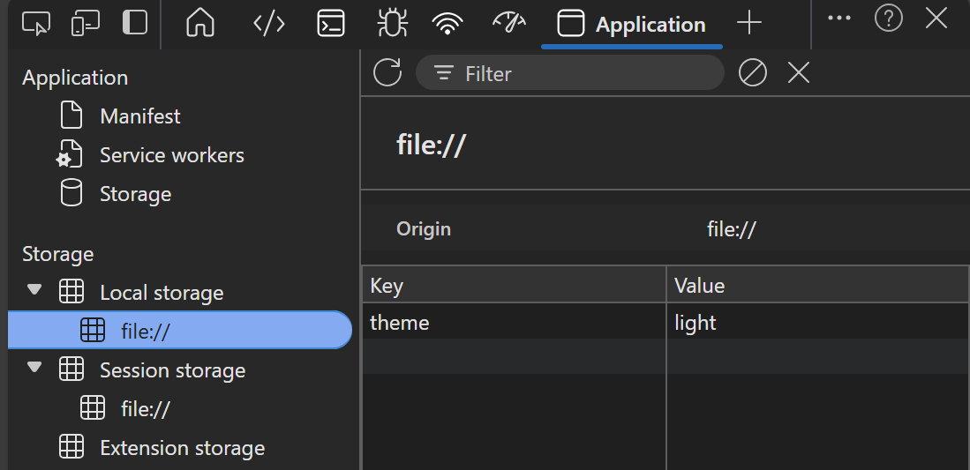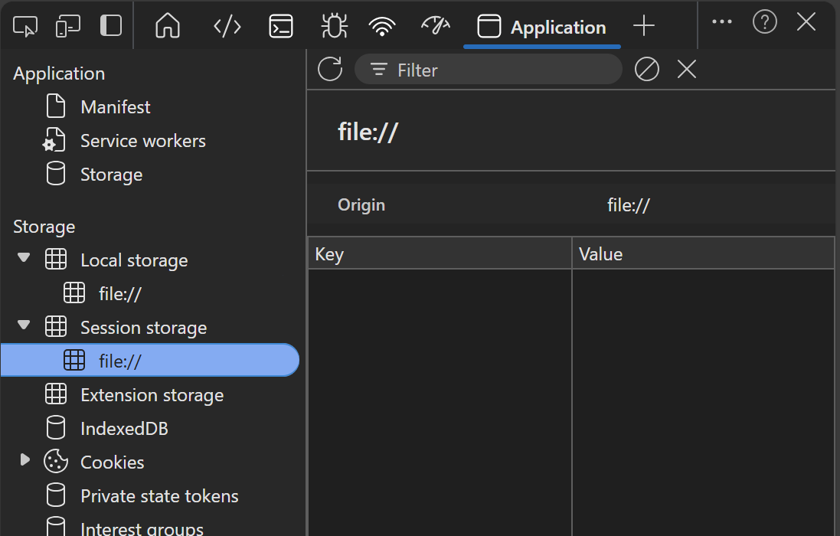

Explanation
- The page loads with the last saved theme from localStorage.
- Clicking the button toggles between light and dark modes.
- The choice persists after reloads.

Task 2: Extend the Theme Switcher
Add:
- A font size preference (small, medium, large).
- Store it in localStorage.
- Apply the font size when the page loads.
Hint:
localStorage.setItem("fontSize", "large");
document.body.style.fontSize = localStorage.getItem("fontSize");
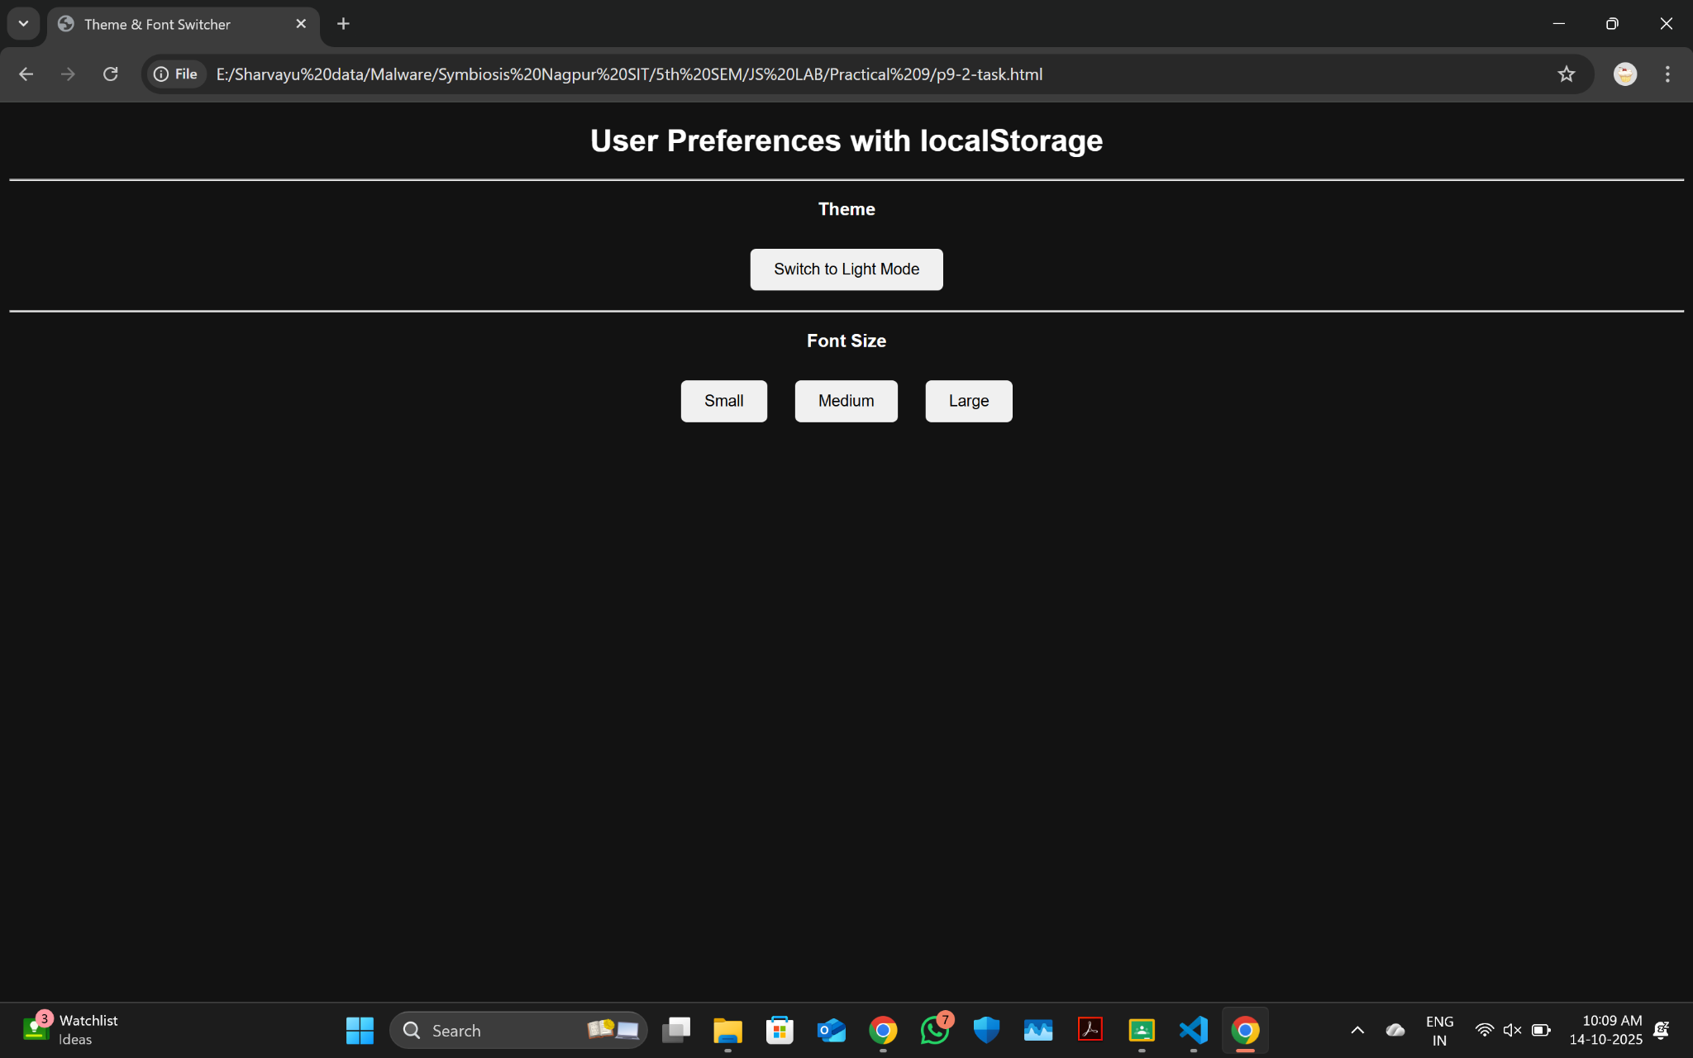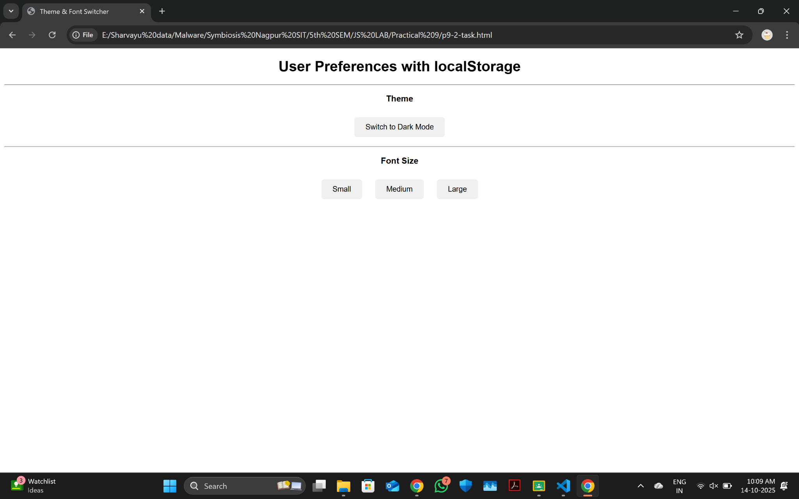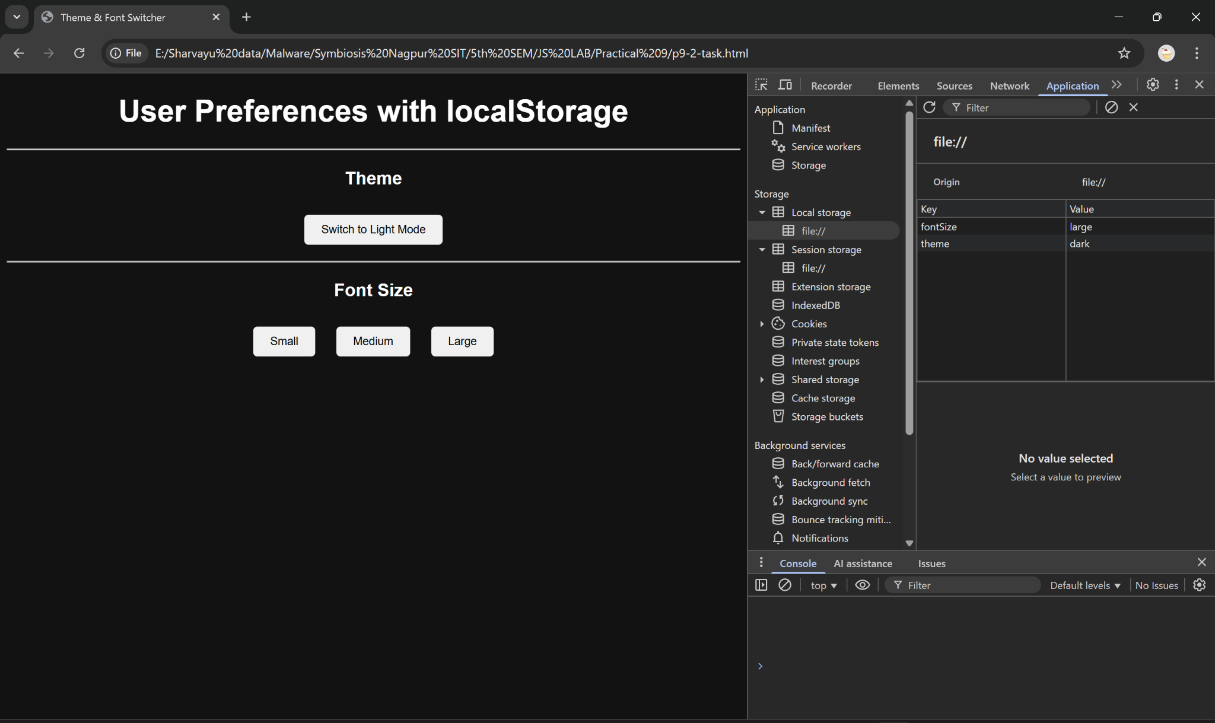

Example 3: Using sessionStorage for Temporary Data
<!DOCTYPE html>
<html lang="en">
<head>
<meta charset="UTF-8">
<title>Session Counter</title>
</head>
<body>
<h2>Session Visit Counter</h2>
<p id="counter"></p>

<script>
if (sessionStorage.getItem("visits")) {
let count = Number(sessionStorage.getItem("visits")) + 1;
sessionStorage.setItem("visits", count);
} else {
sessionStorage.setItem("visits", 1);
}

document.getElementById("counter").textContent =
`You have refreshed this tab ${sessionStorage.getItem("visits")} times.`;
</script>
</body>
</html>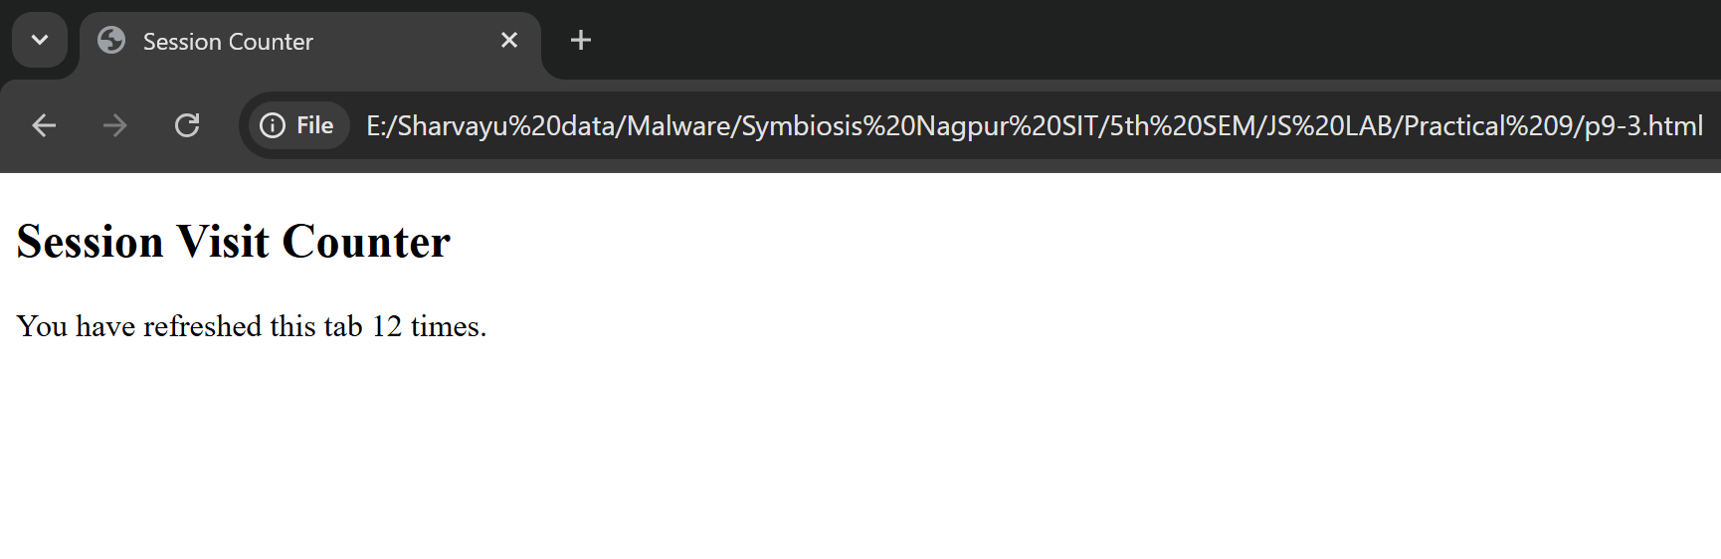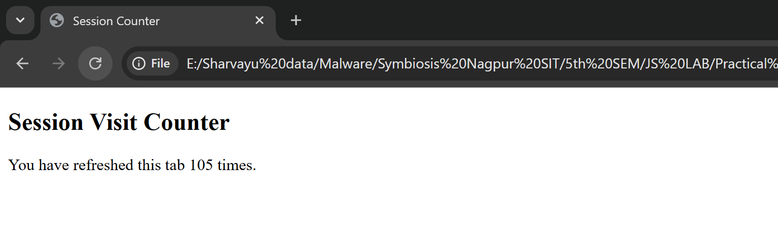

🧾 Explanation
- Counts how many times a tab has been refreshed.
- When tab is closed, the counter resets to 0.

Task 3:
- Create a simple form (name, email, message).
- Save the inputs in sessionStorage as the user types.
- Restore the values when the page reloads (only if the tab is still open).
Hint:
Use the input event and sessionStorage.setItem() for each field.